Database 15.8.2023

<http://localhost:85/attendance/>

add guna link

<http://localhost:85/attendance/add-edit-delete.php?mode=add&name=Rohana&phone=0118675379&email=hana@gmail.com>

phpmyadmin

<http://localhost:85/phpmyadmin/index.php?route=/sql&db=demos&table=users&pos=0>

<https://teachablemachine.withgoogle.com/>

<https://teachablemachine.withgoogle.com/models/z42dcqd3m/>

http://localhost:85/attendance/add-edit-delete.php?mode=add&name=Rohana [Hasan&phone=0118675379&email=cikhana5379@gmail.com](mailto:Hasan&phone=0118675379&email=cikhana5379@gmail.com)

http://localhost:85/attendance/add-edit-delete.php?mode=add&name=Adibah [Ahmad&phone=0133000921&email=adibah.ahmd1008@gmail.com](mailto:Ahmad&phone=0133000921&email=adibah.ahmd1008@gmail.com)

http://localhost:85/attendance/add-edit-delete.php?mode=add&name=farhana [norazman&phone=0176962842&email=farhana@pis.edu.my](mailto:norazman&phone=0176962842&email=farhana@pis.edu.my)

http://localhost:85/attendance/add-edit-delete.php?mode=add&name=Zubydah [Mustafa&phone=0187805898&email=zubydah@pis.edu.my](mailto:Mustafa&phone=0187805898&email=zubydah@pis.edu.my)

Teachable Machine Trigger

<http://localhost:85/ai/>

* Bole buka direct ikut link sbb file dh pindahkan ke htdoc
* Buka ai index.html
* 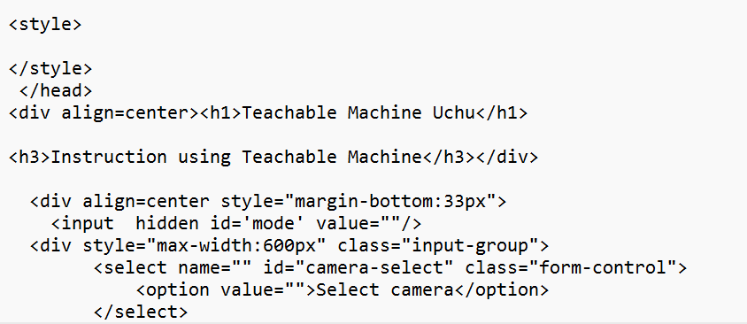

C:\ProgramData\thinkerspace\Tinkercode\tinkercode\ai

<https://teachablemachine.withgoogle.com/models/5T6bnI54S/>

<https://www.dropbox.com/scl/fi/fcsa5qokffcwrgnoth6aj/TinkerCodeAgent3_0_1_Intel.pkg?rlkey=tkqwcjdzkzzt5ycxm9ffb7ril&dl=0>

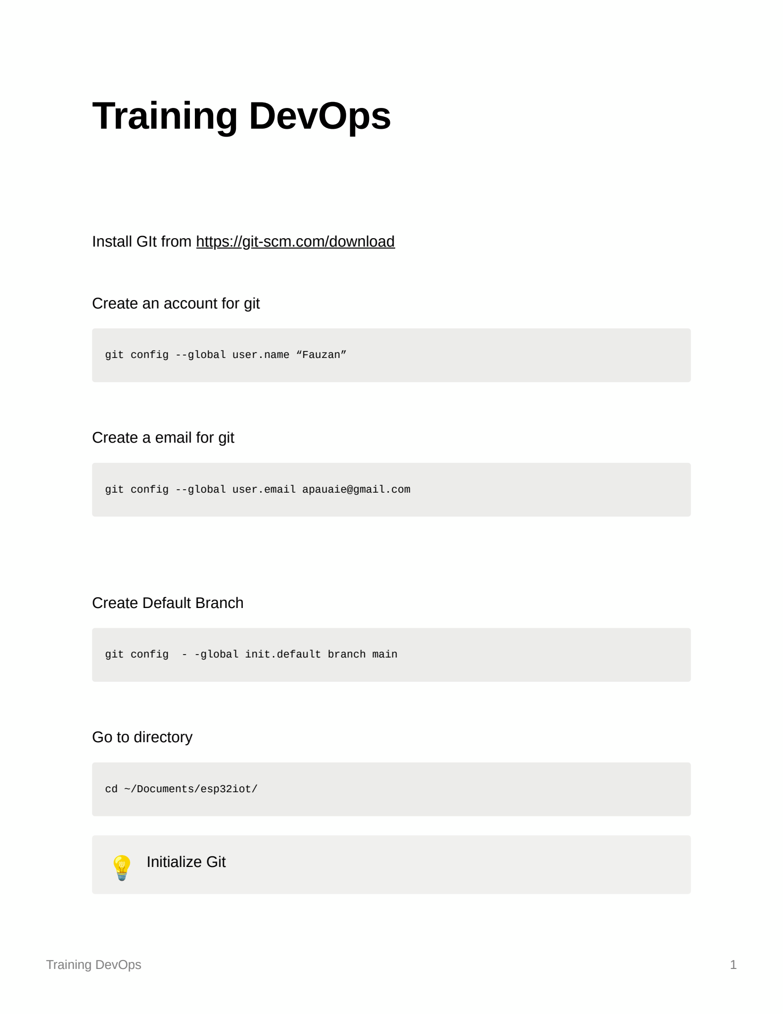

* 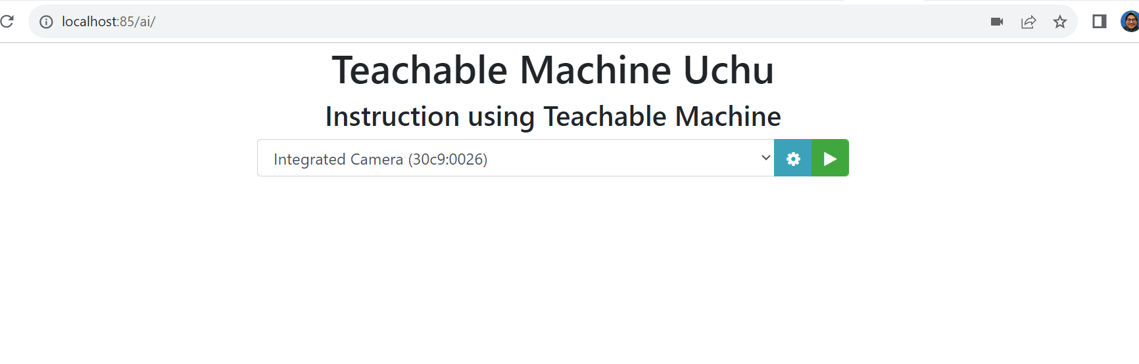

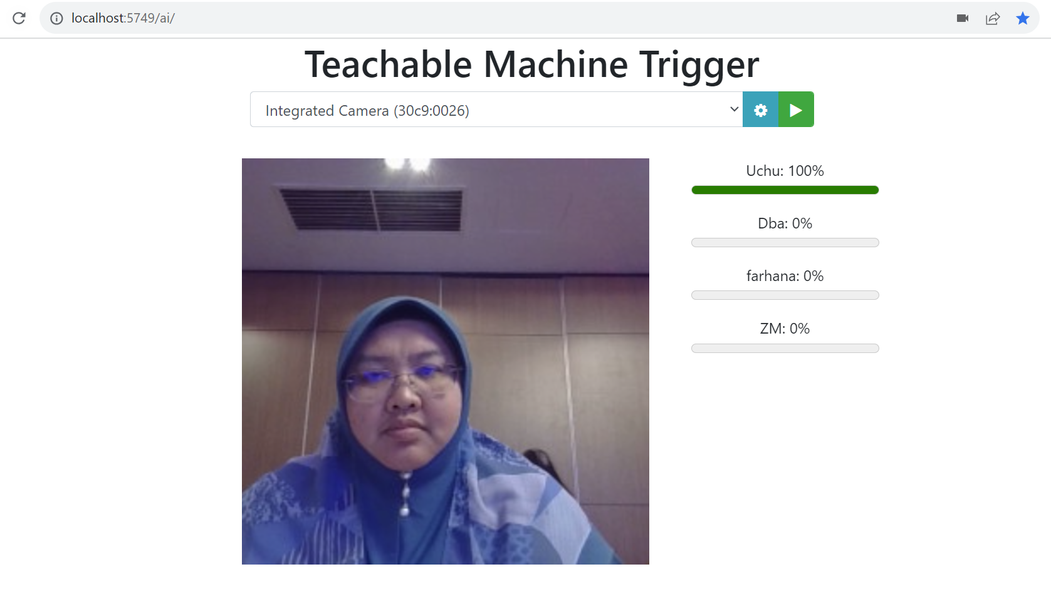

https://www.dropbox.com/scl/fi/b3ii6pkysh7ft2xbf2a2q/Training-GIT.pdf?dl=0&rlkey=2ijf2p1y346x9q6pdyj2men89

git config --global user.name "Uchu"

git config --global user.email [cikhana79@yahoo.com](mailto:cikhana79@yahoo.com)

dir

cd User/

cd Downloads/

mkdir iotcloud

git config --global init.default branch main

cd iotcloud

git init

git status

touch .gitignore

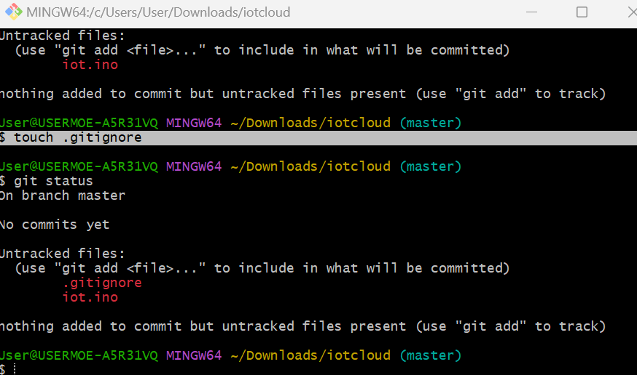

User@USERMOE-A5R31VQ MINGW64 ~

$ git config --global user.name "Uchu"

User@USERMOE-A5R31VQ MINGW64 ~

$ git config --global user.email cikhana79@yahoo.com

User@USERMOE-A5R31VQ MINGW64 ~

$ cd Download

bash: cd: Download: No such file or directory

User@USERMOE-A5R31VQ MINGW64 ~

$ cd download

bash: cd: download: No such file or directory

User@USERMOE-A5R31VQ MINGW64 ~

$ cd ..

User@USERMOE-A5R31VQ MINGW64 /c/Users

$ cd Downloads

bash: cd: Downloads: No such file or directory

User@USERMOE-A5R31VQ MINGW64 /c/Users

$ dir

Administrator Default DefaultAppPool User

All\ Users Default\ User Public desktop.ini

User@USERMOE-A5R31VQ MINGW64 /c/Users

$ cd User/

User@USERMOE-A5R31VQ MINGW64 ~

$ dir

3D\ Objects

AppData

Application\ Data

Contacts

Cookies

Desktop

Documents

Downloads

Favorites

IntelGraphicsProfiles

Links

Local\ Settings

Music

My\ Documents

NTUSER.DAT

NTUSER.DAT{ab7864f5-dcf4-11ed-9544-c11ed87e74a0}.TM.blf

NTUSER.DAT{ab7864f5-dcf4-11ed-9544-c11ed87e74a0}.TMContainer00000000000000000001.regtrans-ms

NTUSER.DAT{ab7864f5-dcf4-11ed-9544-c11ed87e74a0}.TMContainer00000000000000000002.regtrans-ms

NetHood

OneDrive

OneDrive\ -\ pis.edu.my

Pictures

PrintHood

Recent

Saved\ Games

Searches

SendTo

Start\ Menu

Templates

Videos

VirtualBox\ VMs

ntuser.dat.LOG1

ntuser.dat.LOG2

ntuser.ini

User@USERMOE-A5R31VQ MINGW64 ~

$ cd Downloads/

User@USERMOE-A5R31VQ MINGW64 ~/Downloads

$ mkdir iotcloud

User@USERMOE-A5R31VQ MINGW64 ~/Downloads

$ git config --global init.default branch main

User@USERMOE-A5R31VQ MINGW64 ~/Downloads

$ cd iotcloud

User@USERMOE-A5R31VQ MINGW64 ~/Downloads/iotcloud

$ git init

Initialized empty Git repository in C:/Users/User/Downloads/iotcloud/.git/

User@USERMOE-A5R31VQ MINGW64 ~/Downloads/iotcloud (master)

$ git status

On branch master

No commits yet

Untracked files:

(use "git add <file>..." to include in what will be committed)

iot.ino

nothing added to commit but untracked files present (use "git add" to track)

User@USERMOE-A5R31VQ MINGW64 ~/Downloads/iotcloud (master)

$ touch .gitignore

User@USERMOE-A5R31VQ MINGW64 ~/Downloads/iotcloud (master)

$ git status

On branch master

No commits yet

Untracked files:

(use "git add <file>..." to include in what will be committed)

.gitignore

iot.ino

nothing added to commit but untracked files present (use "git add" to track)

User@USERMOE-A5R31VQ MINGW64 ~/Downloads/iotcloud (master)

$ git add .

User@USERMOE-A5R31VQ MINGW64 ~/Downloads/iotcloud (master)

$ git status

On branch master

No commits yet

Changes to be committed:

(use "git rm --cached <file>..." to unstage)

new file: .gitignore

new file: iot.ino

User@USERMOE-A5R31VQ MINGW64 ~/Downloads/iotcloud (master)

$ git commit -m "First Commit"

[master (root-commit) 6341523] First Commit

2 files changed, 87 insertions(+)

create mode 100644 .gitignore

create mode 100644 iot.ino

User@USERMOE-A5R31VQ MINGW64 ~/Downloads/iotcloud (master)

$ git status

On branch master

nothing to commit, working tree clean

User@USERMOE-A5R31VQ MINGW64 ~/Downloads/iotcloud (master)

$ git diff

diff --git a/iot.ino b/iot.ino

index 00922be..e5ea229 100644

--- a/iot.ino

+++ b/iot.ino

@@ -60,8 +60,7 @@ int pinValue = param.asInt();

pixels.setPixelColor(1, 0x3333ff);

pixels.setPixelColor(2, 0x3333ff);

pixels.setPixelColor(3, 0x3333ff);

- pixels.setPixelColor(4, 0x3333ff);

- pixels.show();

+ pixels.show();

pixels.show();

}

User@USERMOE-A5R31VQ MINGW64 ~/Downloads/iotcloud (master)

$ git diff

diff --git a/iot.ino b/iot.ino

index 00922be..99f7726 100644

--- a/iot.ino

+++ b/iot.ino

@@ -61,7 +61,8 @@ int pinValue = param.asInt();

pixels.setPixelColor(2, 0x3333ff);

pixels.setPixelColor(3, 0x3333ff);

pixels.setPixelColor(4, 0x3333ff);

- pixels.show();

+ pixels.show();

+ pixels.show();

pixels.show();

}

User@USERMOE-A5R31VQ MINGW64 ~/Downloads/iotcloud (master)

$ git diff

diff --git a/iot.ino b/iot.ino

index 00922be..61d5cc5 100644

--- a/iot.ino

+++ b/iot.ino

@@ -61,7 +61,7 @@ int pinValue = param.asInt();

pixels.setPixelColor(2, 0x3333ff);

pixels.setPixelColor(3, 0x3333ff);

pixels.setPixelColor(4, 0x3333ff);

- pixels.show();

+ pixels.show();

pixels.show();

}

User@USERMOE-A5R31VQ MINGW64 ~/Downloads/iotcloud (master)

$ git diff

User@USERMOE-A5R31VQ MINGW64 ~/Downloads/iotcloud (master)

$ git add .

User@USERMOE-A5R31VQ MINGW64 ~/Downloads/iotcloud (master)

$ git commit -a -m 'pengenalan'

[master 93a19e0] pengenalan

1 file changed, 0 insertions(+), 0 deletions(-)

create mode 100644 Pengenalan kepada Google Site.pdf

User@USERMOE-A5R31VQ MINGW64 ~/Downloads/iotcloud (master)

$ git status

On branch master

nothing to commit, working tree clean

User@USERMOE-A5R31VQ MINGW64 ~/Downloads/iotcloud (master)

$ git status

On branch master

Changes not staged for commit:

(use "git add/rm <file>..." to update what will be committed)

(use "git restore <file>..." to discard changes in working directory)

deleted: Pengenalan kepada Google Site.pdf

no changes added to commit (use "git add" and/or "git commit -a")

User@USERMOE-A5R31VQ MINGW64 ~/Downloads/iotcloud (master)

$ git restore pengenalan.pdf

error: pathspec 'pengenalan.pdf' did not match any file(s) known to git

User@USERMOE-A5R31VQ MINGW64 ~/Downloads/iotcloud (master)

$ git restore Pengenalan.pdf

error: pathspec 'Pengenalan.pdf' did not match any file(s) known to git

User@USERMOE-A5R31VQ MINGW64 ~/Downloads/iotcloud (master)

$ git restore Pengenalan kepada Google site.pdf

error: pathspec 'Pengenalan' did not match any file(s) known to git

error: pathspec 'kepada' did not match any file(s) known to git

error: pathspec 'Google' did not match any file(s) known to git

error: pathspec 'site.pdf' did not match any file(s) known to git

User@USERMOE-A5R31VQ MINGW64 ~/Downloads/iotcloud (master)

$ git restore Pengenalan kepada Google Site.pdf

error: pathspec 'Pengenalan' did not match any file(s) known to git

error: pathspec 'kepada' did not match any file(s) known to git

error: pathspec 'Google' did not match any file(s) known to git

error: pathspec 'Site.pdf' did not match any file(s) known to git

User@USERMOE-A5R31VQ MINGW64 ~/Downloads/iotcloud (master)

$ git commit -a 'Pengenalan'

fatal: paths 'Pengenalan ...' with -a does not make sense

User@USERMOE-A5R31VQ MINGW64 ~/Downloads/iotcloud (master)

$ git commit -m 'Pengenalan'

On branch master

Changes not staged for commit:

(use "git add/rm <file>..." to update what will be committed)

(use "git restore <file>..." to discard changes in working directory)

deleted: Pengenalan kepada Google Site.pdf

no changes added to commit (use "git add" and/or "git commit -a")

User@USERMOE-A5R31VQ MINGW64 ~/Downloads/iotcloud (master)

$ git restore "Pengenalan kepada Google Site.pdf"

User@USERMOE-A5R31VQ MINGW64 ~/Downloads/iotcloud (master)

$ git log

commit 93a19e04ca5d89e6a954f51f4c073e8acf48d665 (HEAD -> master)

Author: Uchu <cikhana79@yahoo.com>

Date: Tue Aug 15 16:08:10 2023 +0800

pengenalan

commit 634152372d53bd60ee62f04996583ae85f1ee301

Author: Uchu <cikhana79@yahoo.com>

Date: Tue Aug 15 15:18:21 2023 +0800

First Commit

User@USERMOE-A5R31VQ MINGW64 ~/Downloads/iotcloud (master)

$ git log --online

fatal: unrecognized argument: --online

User@USERMOE-A5R31VQ MINGW64 ~/Downloads/iotcloud (master)

$ git log --oneline

93a19e0 (HEAD -> master) pengenalan

6341523 First Commit

User@USERMOE-A5R31VQ MINGW64 ~/Downloads/iotcloud (master)

$ git diff

diff --git a/iot.ino b/iot.ino

index 00922be..7351040 100644

--- a/iot.ino

+++ b/iot.ino

@@ -30,7 +30,6 @@ int pinValue = param.asInt();

digitalWrite(13,HIGH);

digitalWrite(14,LOW);

analogWrite(25,220);

- digitalWrite(18,HIGH);

digitalWrite(19,LOW);

analogWrite(15,200);

@@ -39,7 +38,6 @@ int pinValue = param.asInt();

digitalWrite(14,LOW);

analogWrite(25,100);

digitalWrite(18,HIGH);

- digitalWrite(19,LOW);

analogWrite(15,100);

pixels.setPixelColor(0, 0x000000);

pixels.setPixelColor(1, 0x000000);

@@ -59,7 +57,6 @@ int pinValue = param.asInt();

pixels.setPixelColor(0, 0x3333ff);

pixels.setPixelColor(1, 0x3333ff);

pixels.setPixelColor(2, 0x3333ff);

- pixels.setPixelColor(3, 0x3333ff);

pixels.setPixelColor(4, 0x3333ff);

pixels.show();

pixels.show();

User@USERMOE-A5R31VQ MINGW64 ~/Downloads/iotcloud (master)

$ git status

On branch master

Changes not staged for commit:

(use "git add <file>..." to update what will be committed)

(use "git restore <file>..." to discard changes in working directory)

modified: iot.ino

no changes added to commit (use "git add" and/or "git commit -a")

User@USERMOE-A5R31VQ MINGW64 ~/Downloads/iotcloud (master)

$ git add .

User@USERMOE-A5R31VQ MINGW64 ~/Downloads/iotcloud (master)

$ git diff

User@USERMOE-A5R31VQ MINGW64 ~/Downloads/iotcloud (master)

$ git diff

diff --git a/iot.ino b/iot.ino

index 7351040..47a8880 100644

--- a/iot.ino

+++ b/iot.ino

@@ -30,6 +30,7 @@ int pinValue = param.asInt();

digitalWrite(13,HIGH);

digitalWrite(14,LOW);

analogWrite(25,220);

+ digitalWrite(18,HIGH);

digitalWrite(19,LOW);

analogWrite(15,200);

User@USERMOE-A5R31VQ MINGW64 ~/Downloads/iotcloud (master)

$ git diff

diff --git a/iot.ino b/iot.ino

index 7351040..c55ffab 100644

--- a/iot.ino

+++ b/iot.ino

@@ -30,6 +30,7 @@ int pinValue = param.asInt();

digitalWrite(13,HIGH);

digitalWrite(14,LOW);

analogWrite(25,220);

+ digitalWrite(18,HIGH);

digitalWrite(19,LOW);

analogWrite(15,200);

@@ -38,6 +39,7 @@ int pinValue = param.asInt();

digitalWrite(14,LOW);

analogWrite(25,100);

digitalWrite(18,HIGH);

+ digitalWrite(19,LOW);

analogWrite(15,100);

pixels.setPixelColor(0, 0x000000);

pixels.setPixelColor(1, 0x000000);

User@USERMOE-A5R31VQ MINGW64 ~/Downloads/iotcloud (master)

$ git diff

diff --git a/iot.ino b/iot.ino

index 7351040..00922be 100644

--- a/iot.ino

+++ b/iot.ino

@@ -30,6 +30,7 @@ int pinValue = param.asInt();

digitalWrite(13,HIGH);

digitalWrite(14,LOW);

analogWrite(25,220);

+ digitalWrite(18,HIGH);

digitalWrite(19,LOW);

analogWrite(15,200);

@@ -38,6 +39,7 @@ int pinValue = param.asInt();

digitalWrite(14,LOW);

analogWrite(25,100);

digitalWrite(18,HIGH);

+ digitalWrite(19,LOW);

analogWrite(15,100);

pixels.setPixelColor(0, 0x000000);

pixels.setPixelColor(1, 0x000000);

@@ -57,6 +59,7 @@ int pinValue = param.asInt();

pixels.setPixelColor(0, 0x3333ff);

pixels.setPixelColor(1, 0x3333ff);

pixels.setPixelColor(2, 0x3333ff);

+ pixels.setPixelColor(3, 0x3333ff);

pixels.setPixelColor(4, 0x3333ff);

pixels.show();

pixels.show();

User@USERMOE-A5R31VQ MINGW64 ~/Downloads/iotcloud (master)

$ git status

On branch master

Changes to be committed:

(use "git restore --staged <file>..." to unstage)

modified: iot.ino

Changes not staged for commit:

(use "git add <file>..." to update what will be committed)

(use "git restore <file>..." to discard changes in working directory)

modified: iot.ino

User@USERMOE-A5R31VQ MINGW64 ~/Downloads/iotcloud (master)

$ git log

commit 93a19e04ca5d89e6a954f51f4c073e8acf48d665 (HEAD -> master)

Author: Uchu <cikhana79@yahoo.com>

Date: Tue Aug 15 16:08:10 2023 +0800

pengenalan

commit 634152372d53bd60ee62f04996583ae85f1ee301

Author: Uchu <cikhana79@yahoo.com>

Date: Tue Aug 15 15:18:21 2023 +0800

First Commit

User@USERMOE-A5R31VQ MINGW64 ~/Downloads/iotcloud (master)

$ git commit -a -m '2nd Commit'

On branch master

nothing to commit, working tree clean

User@USERMOE-A5R31VQ MINGW64 ~/Downloads/iotcloud (master)

$ git diff

diff --git a/iot.ino b/iot.ino

index 7351040..00922be 100644

--- a/iot.ino

+++ b/iot.ino

@@ -30,6 +30,7 @@ int pinValue = param.asInt();

digitalWrite(13,HIGH);

digitalWrite(14,LOW);

analogWrite(25,220);

+ digitalWrite(18,HIGH);

digitalWrite(19,LOW);

analogWrite(15,200);

@@ -38,6 +39,7 @@ int pinValue = param.asInt();

digitalWrite(14,LOW);

analogWrite(25,100);

digitalWrite(18,HIGH);

+ digitalWrite(19,LOW);

analogWrite(15,100);

pixels.setPixelColor(0, 0x000000);

pixels.setPixelColor(1, 0x000000);

@@ -57,6 +59,7 @@ int pinValue = param.asInt();

pixels.setPixelColor(0, 0x3333ff);

pixels.setPixelColor(1, 0x3333ff);

pixels.setPixelColor(2, 0x3333ff);

+ pixels.setPixelColor(3, 0x3333ff);

pixels.setPixelColor(4, 0x3333ff);

pixels.show();

pixels.show();

User@USERMOE-A5R31VQ MINGW64 ~/Downloads/iotcloud (master)

$ git status

On branch master

Changes to be committed:

(use "git restore --staged <file>..." to unstage)

modified: iot.ino

Changes not staged for commit:

(use "git add <file>..." to update what will be committed)

(use "git restore <file>..." to discard changes in working directory)

modified: iot.ino

User@USERMOE-A5R31VQ MINGW64 ~/Downloads/iotcloud (master)

$ git branch repair

User@USERMOE-A5R31VQ MINGW64 ~/Downloads/iotcloud (master)

$ git branch

\* master

repair

User@USERMOE-A5R31VQ MINGW64 ~/Downloads/iotcloud (master)

$ git switch repair

Switched to branch 'repair'

M iot.ino

User@USERMOE-A5R31VQ MINGW64 ~/Downloads/iotcloud (repair)

$ git commit -m 'fixed servo'

[repair 4f94f8a] fixed servo

1 file changed, 3 deletions(-)

User@USERMOE-A5R31VQ MINGW64 ~/Downloads/iotcloud (repair)

$ git switch main

fatal: invalid reference: main

User@USERMOE-A5R31VQ MINGW64 ~/Downloads/iotcloud (repair)

$ git switch repair

Already on 'repair'

M iot.ino

User@USERMOE-A5R31VQ MINGW64 ~/Downloads/iotcloud (repair)

$ git switch main

fatal: invalid reference: main

User@USERMOE-A5R31VQ MINGW64 ~/Downloads/iotcloud (repair)

$ git commit -m 'fixed servo'

On branch repair

Changes not staged for commit:

(use "git add <file>..." to update what will be committed)

(use "git restore <file>..." to discard changes in working directory)

modified: iot.ino

no changes added to commit (use "git add" and/or "git commit -a")

User@USERMOE-A5R31VQ MINGW64 ~/Downloads/iotcloud (repair)

$ git switch main

fatal: invalid reference: main

User@USERMOE-A5R31VQ MINGW64 ~/Downloads/iotcloud (repair)

$ git branch

master

\* repair

User@USERMOE-A5R31VQ MINGW64 ~/Downloads/iotcloud (repair)

$ git switch repair

Already on 'repair'

M iot.ino

User@USERMOE-A5R31VQ MINGW64 ~/Downloads/iotcloud (repair)

$ git switch main

fatal: invalid reference: main

User@USERMOE-A5R31VQ MINGW64 ~/Downloads/iotcloud (repair)

$ git switch main

fatal: invalid reference: main

User@USERMOE-A5R31VQ MINGW64 ~/Downloads/iotcloud (repair)

$ git switch master

error: Your local changes to the following files would be overwritten by checkout:

iot.ino

Please commit your changes or stash them before you switch branches.

Aborting

User@USERMOE-A5R31VQ MINGW64 ~/Downloads/iotcloud (repair)

$ git switch master

error: Your local changes to the following files would be overwritten by checkout:

iot.ino

Please commit your changes or stash them before you switch branches.

Aborting

User@USERMOE-A5R31VQ MINGW64 ~/Downloads/iotcloud (repair)

$ git switch master

error: Your local changes to the following files would be overwritten by checkout:

iot.ino

Please commit your changes or stash them before you switch branches.

Aborting

User@USERMOE-A5R31VQ MINGW64 ~/Downloads/iotcloud (repair)

$ git commit -a -m 'repair'

[repair 0b9a4f6] repair

1 file changed, 4 insertions(+), 4 deletions(-)

User@USERMOE-A5R31VQ MINGW64 ~/Downloads/iotcloud (repair)

$ git switch master

Switched to branch 'master'

User@USERMOE-A5R31VQ MINGW64 ~/Downloads/iotcloud (master)

$ git merge -m 'repair servo x' repair

Updating 93a19e0..0b9a4f6

Fast-forward (no commit created; -m option ignored)

iot.ino | 5 +----

1 file changed, 1 insertion(+), 4 deletions(-)

User@USERMOE-A5R31VQ MINGW64 ~/Downloads/iotcloud (master)

$ git switch repair

Switched to branch 'repair'

User@USERMOE-A5R31VQ MINGW64 ~/Downloads/iotcloud (repair)

$ git switch master

Switched to branch 'master'

User@USERMOE-A5R31VQ MINGW64 ~/Downloads/iotcloud (master)

$ git branch -d repair

Deleted branch repair (was 0b9a4f6).

User@USERMOE-A5R31VQ MINGW64 ~/Downloads/iotcloud (master)

$